SainSmart 6-Axis Servos Control Palletizing Robot Arm Model User Guide

Power supply requirements.
- Arduino UNO can be powered by USB interface, and the voltage requirement is 5V. (USB port can meet power supply)
- Because the current required by the steering gear is relatively high, the load can reach 1A. The steering gear shield is powered by a DC power supply alone, and the voltage is 5V.
Note: The VCC of the steering gear shield is connected to the VCC of the Arduino UNO board. The voltage of the shield cannot exceed 5V, otherwise the Arduino UNO will be damaged.
#Recommended to use UNI-T UTP3315TFL-II DC Power Supply
https://www.sainsmart.com/products/uni-t-utp3315tfl-ii-dc-power-supply

- Connect servo motor with extension shield
Servo motor signal wire is orange or white color, Define servo 1-6 and connect servo with PIN3、PIN5、PIN6、PIN9、PIN10 and PIN11 as diagram.
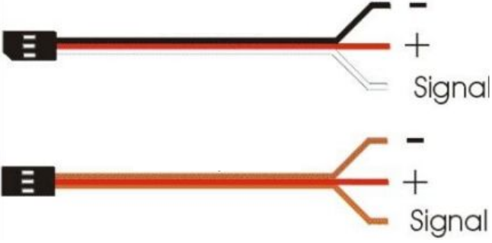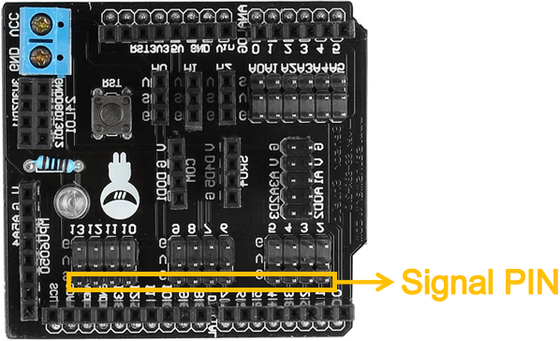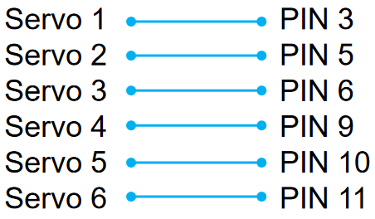
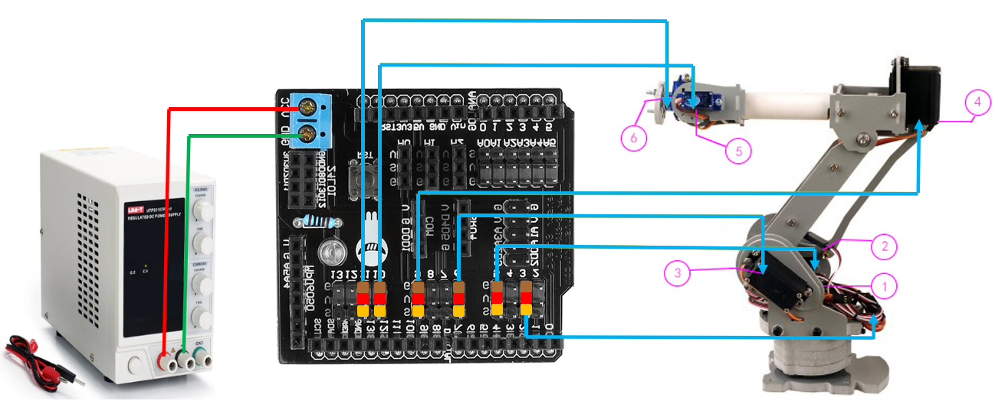

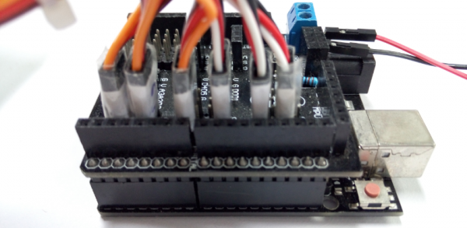

- Test code sample
Firstly, check your Arduino IDE software library whether you already installed latest servo library.
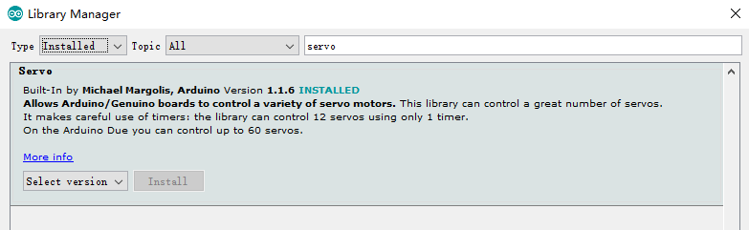
1.Run “Auto” code and check servo whether working normally
2.Run “Serial” code and control servo by Serial Monitor
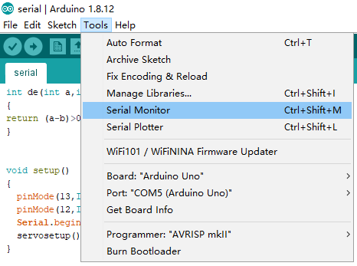
Input control code in Serial Monitor. For example,c120 means order servoC turn to 120°.
Warning: Use lower-case letters ，“c” is right, “C” is wrong.
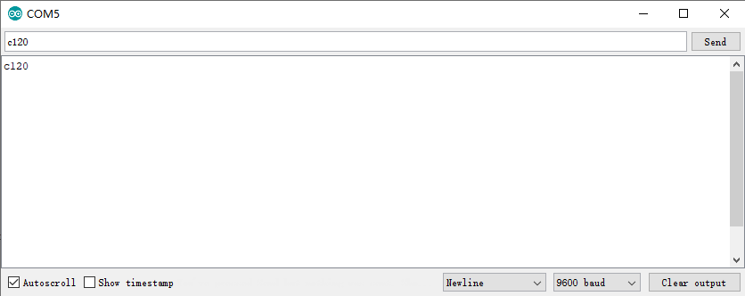
Tips: You should take off servo extension shield before you upload code to Arduino because servo will Influence USB electric current and defeat code upload process.

Learn servo library
https://www.arduino.cc/en/reference/servo
